**Visualizing Network Optimization Model Results using Python**

A quick way to validate network optimization model results is visually creating optimal flow maps which show flows between source and destination. This post explains how to create such visualizations using Python.

Consider the algorithm in the “Greenfield Analysis” post. The output of the algorithm is allocations of distribution centers to customers which is called optimal flows map. Figures 1 and 2 shows customer locations and optimal flows maps, respectively.

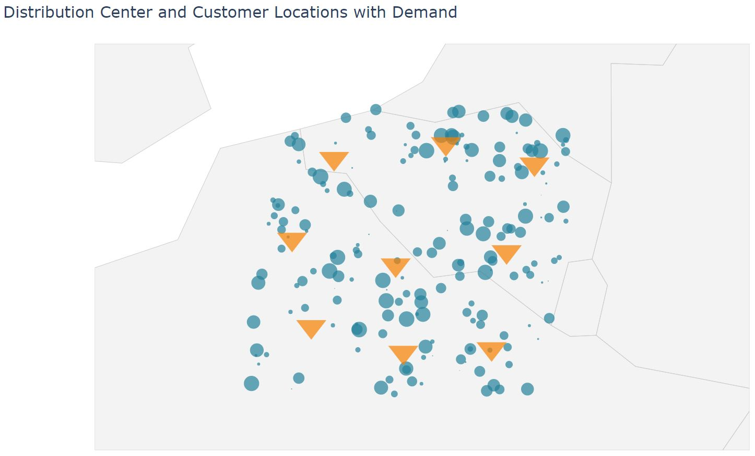

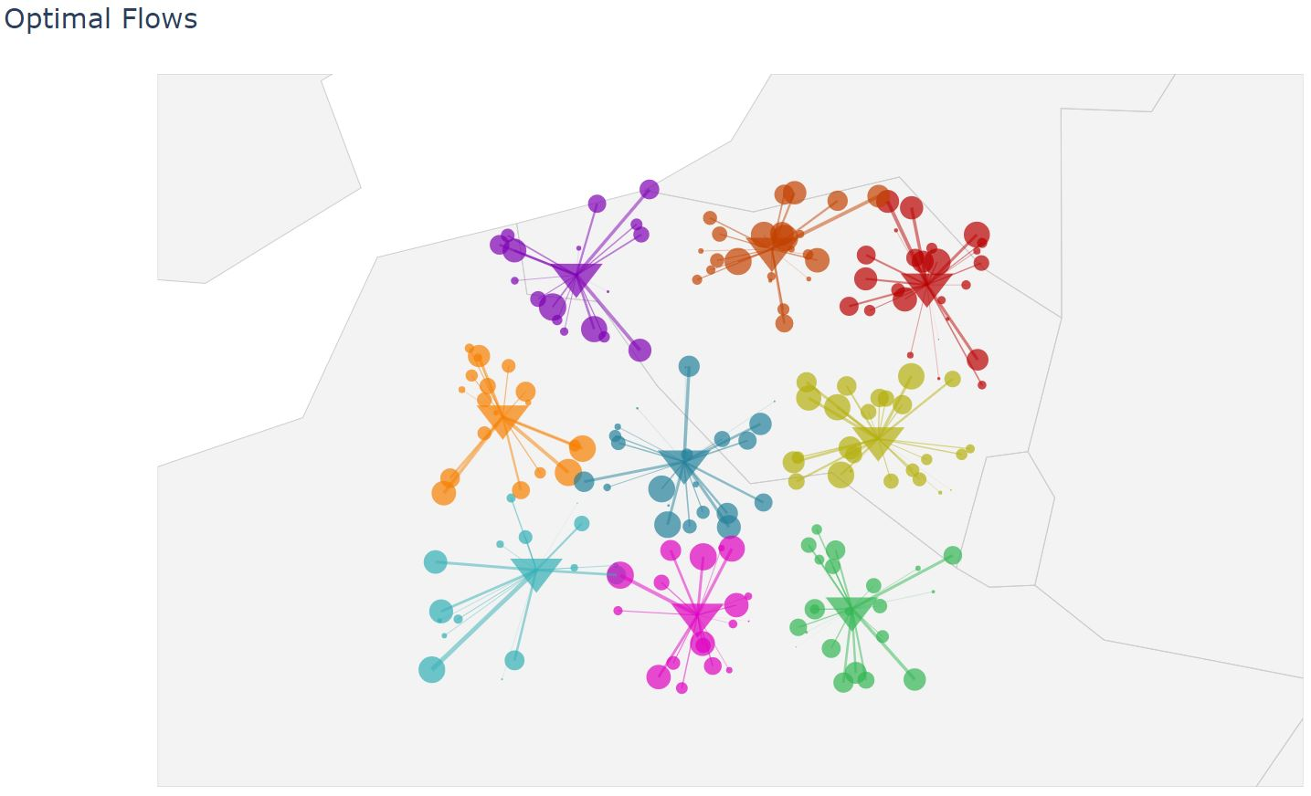

| ![_config.yml]({{ site.baseurl }}/images/2019-7-30_allocation_map.jpg) |  
|:--:|   
| *Figure 1: Optimal flow map* |

Python can be used to create customer location and optimal flows maps quickly. This helps modelers to validate modeling inputs and results.

## Application

We use results from the “Greenfield Analysis”. We use this data set to build

* Customer locations map
* Optimal flows map

In the python code, we first initiate libraries and read the results data

## Customer locations map

## Customer Locations Map